Quick guide mortar pumps S30 / S30HD40
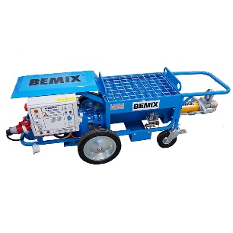
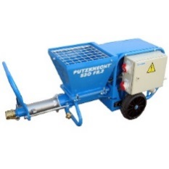

S30 S30HD40

Before starting
Goggles, gloves, helmet and safety shoes (PPE) should always be used when working with pump equipment. Only trained personnel should use the pump equipment. Make sure the pump is only used in a safe manner. Do not remove the protective grille on top of the hopper.

Place the pump on a hard, flat surface as close to the location where the material will be pumped as possible. Roll out the hose completely and set the mixer next to the pump so that you can access the toolbox on the pump. Connect the power to the mixer and the pump, 3 phase and fuse to 25A per machine. Fill the hopper with water and test start the pump by turning the power switch on and press the "start", either on the control box panel or remote control. Check also that the screw in the hopper spins in the correct direction, counterclockwise. Turn off quickly and prepare slurry, a loose mixture of cement and water to a "porridge" -like consistency.

Pumping
Connect the pipe to the pump. Pour the slurry (cement and water mixture) into the hopper. Start the pump and run the slurry through the hose. Mix the mortar to the correct consistency in the mixer, open the hatch, and let the mortar run down into the hopper and keep on pumping. Ensure that there are mortar that cover the opening to the outlet of the pump hopper at all time to avoid air in the hoses. Always keep an eye and hold tightly to the end of the hose so that the mortar does not end up in an undesirable place. Adjust the speed of the pump only when it is running with the control on the panel on the control box.

Cleaning
Pump as much as possible out of the material without running the stator and rotor dry. Turn off the pump and restart it with the “reverse button” pressed to reverse and release the pressure in the hose, see when the pressure clock is set to “0”. When releasing the pressure, it is ok to disconnect the hose. Note that always turn your head away from the pump at the time of opening. Rinse and clean the hopper, preferably use a wash brush. Open the drainage opening at the bottom of the hopper and rinse clean. When the tub is clean, close the drainage opening. Fill the hopper with water and start the pump for a short while to clean the stator and rotor. Also, take a wash brush and water at the outlet and clean it thoroughly. Take a sponge out of the toolbox, soak it in water and push into the hose, connect the cleaning connector located in the toolbox. Connect a water hose to the cleaning connector and flush water through the pipe, repeat a few times until the pipe is clean. In the tool box there is a grease gun, lubricate motor flanges via nipple until grease comes out of the seal at the trough.

TIP!
Drain hose out of water, it is particularly important in winter if the hose is stored outdoors when the ice plugs can be easily formed in the hose. It is advisable to disassemble the stator and rotor once a week for longer durability and longevity.



It does not work
The pump does not start; check all fuses are ok. If no light on the panel lights up, check the inverter and adjust the glove. If phases are missing, waiting time may be 2-3 minutes before switched on again. Ensure that all power cables are intact.
Stop in the hose, if the hose is not lubricated properly is a major risk for separation of the mortar, which easily causes the stop or sand plug. Stop the pump and back pressure off, check the pressure clock indicates "0". Disconnect the hose; always turn the face away from the pump! Shake and turn on the hose to release the plug, clean by inserting a water hose and rinse. Ultimately, cutting any hoses at plug but save couplings.

If the pump goes in the wrong direction, stop the pump and turn the switch in the opposite direction. Make sure that the hose is not folded, e.g. over floors, walls or around corners.
At long break or stops, start the cleaning process as soon as possible and start from scratch.

Checking the rotor and stator
Fill the hopper with some water and installing test pressure clock available in the toolbox. Start the machine when the tap is open, close and read the meter, it should be at least 15 bar. Turn off the pump, open the drainage plug, open the valve and release the pressure. Disconnect the test pressure clock.

Warning
Always use protection gear like gloves, glasses, helmet and shoes. Always aim the hose outlet away from you. Never let go of the pipe outlet while pumping, clear risk of getting mortar where you do not want it. If moving while pumping, make sure that, the hose never folds. Always make sure that the hose are well lubricated with a slurry before pumping to avoid stops. Do not store the hose and machine outdoors in cold weather, as there is a risk of icing in them. Do not disconnect the hose if it is under pressure from the machine, reverse the pump to reduce the pressure, and then disconnect the hose. If the hose is very hard to touch, there is pressure from the machine, put the pump in revers and feel the hose again, is it softer there is now less pressure in the pump hose. Always turn the face away from the pump when disconnecting the hose from the pump outlet. When cleaning the hose, follow the instructions above; do not attempt to clean the hose without sponge, risk of separation and sand plug. Always follow the instructions on the bags mixed. Latest and updated instructions are always on www.bemix.se

